Estimated Glomerular Filtration Rate (eGFR) Slope
Renal Function Trajectory Electronic Phenotype (e-Phenotype) Algorithm
Documentation and Pseudo Code V4B
Columbia University
PheKB: https://phekb.org/phenotype/egfr-slope
Contacts:
Ning “Sunny” Shang (ns3026@cumc.columbia.edu)
Atlas Khan (ak4046@cumc.columbia.edu)
Krzysztof Kiryluk (kk473@cumc.columbia.edu)

I. Background and Significance
Chronic kidney disease (CKD) is a progressive condition affecting an estimated 10-15% of the global population, and it is a major cause of morbidity and mortality worldwide [1]. Disease severity is conventionally graded by the estimated glomerular filtration rate (eGFR), which is widely accepted as the best overall index of kidney function [4]. Most prior epidemiologic and genetic studies of kidney function have relied on a single time-point eGFR. A single cross-sectional eGFR, however, is prone to confounding by age, sex, genetic ancestry, and muscle mass, and may not accurately reflect kidney function under transient physiologic states [1].
eGFR slope -- the rate of change in eGFR over time -- captures the longitudinal trajectory of kidney function rather than a single snapshot. The rate of eGFR decline is a clinically meaningful marker of CKD progression and is strongly associated with the risk of end-stage kidney disease (ESKD) and mortality [5,6]. The decline in eGFR has emerged as a more robust predictor of kidney dysfunction than albuminuria alone, and distinct eGFR-decline trajectories have been linked to ESKD and death in patients with type 1 and type 2 diabetes [5].
From a genetics standpoint, a longitudinal phenotype of renal function decline may capture CKD risk that cross-sectional analyses miss, since partly distinct genetic and environmental factors may drive the decline in kidney function over time. Cross-sectional GWAS have identified hundreds of loci for single time-point eGFR, but kidney-function-decline GWAS have been limited by short follow-up and small samples. A scalable, reproducible electronic phenotype (e-phenotype) for eGFR slope derived from electronic health records (EHRs) therefore enables large-scale, longitudinal studies of kidney disease progression.
This algorithm defines a portable, computable e-phenotype that derives each subject’s chronic eGFR trajectory (eGFR slope) from routinely collected EHR serum creatinine (SCr) measurements. The core design goal is to isolate the chronic component of kidney-function change by removing noise introduced by acute illness, implausible measurements, and short-term variability, so that the resulting slope reflects meaningful long-term change. The phenotype is intended for cohort selection and as a quantitative trait in genetic and epidemiologic studies of CKD progression, and it has been validated by phenome-wide (PheWAS) and genome-wide (GWAS) association analyses across multiple biobanks [1].
Key challenges addressed. The eGFR estimating equation is valid only under steady-state conditions, in the absence of renal replacement therapy or acute kidney injury (AKI) [2,3]. Serum creatinine fluctuates with volume depletion, shock, sepsis, and AKI, and EHR data contain implausible values, irregular sampling, and measurements taken after renal replacement therapy. The algorithm uses a series of biologically informed filters and a defined baseline/termination window to mitigate these issues.

II. Development
- The eGFR slope phenotype was developed on structured EHR data using domain knowledge and clinical standards, building on the Columbia University CKD e-phenotype framework.
- The implementation is written as a parameterized and modularized query so that it is portable across diverse EHR systems and terminologies [7]. Code dictionary and schema/table/field names are supplied as parameters and injected at execution time; only the data-extraction block needs site-specific customization.
- The reference implementation documented here targets the OMOP Common Data Model (standard concept IDs for measurements, conditions, procedures, observations, and visits).
- Validation was performed across multiple large biobanks (such as eMERGE-III, the All of Us Research Program). The algorithmically derived slope showed expected associations with CKD and its comorbidities by PheWAS and recovered known kidney-function loci (e.g., UMOD) by GWAS [1].

III. Algorithm Definition (Figure 1)
The algorithm implementation is summarized in Figure 1. Key definitions used throughout are given below.

Core definitions
- Qualifying (“legit”) eGFR: an eGFR derived from an adult (≥18 years) SCr measurement that survives all exclusion filters (eGFR Filter 1 and eGFR Filter 2).
- Baseline eGFR: the highest qualifying eGFR recorded within the first three months after the subject’s first qualifying eGFR.
- Termination eGFR: the last qualifying eGFR before any termination trigger event; if no trigger event occurs, the latest available qualifying eGFR is used.
- Termination trigger events: first dialysis, first kidney transplant, first ESRD diagnosis, first eGFR < 15 mL/min/1.73 m², or first eGFR spike.
- eGFR spike: an increase in eGFR of more than 50% within 24 hours (relative to the lowest qualifying eGFR on the previous day). Spikes likely reflect dialysis missed by procedure codes or recovery from acute illness rather than true long-term trends.
- Acute condition (co-occurrence): AKI, prerenal kidney injury, sepsis, volume depletion, shock, or an ICU visit. An eGFR “co-occurs” with an acute condition if it falls during the condition or within a 14-day window before or after it.
- eGFR slope: the change in eGFR per year (mL/min/1.73 m² per year).

Processing stages
- Extract & clean SCr; calculate eGFR. Remove SCr = 0; if multiple SCr are recorded at the same minute, keep the maximum value; compute eGFR with the CKD-EPI 2021 (race-free) creatinine equation [2].
- eGFR Filter 1 -- exclude an eGFR if any: corresponding SCr < 0, eGFR < 0, or eGFR ≥ 175; eGFR age < 18 years; the value falls after the first dialysis, kidney transplant, ESRD, or eGFR < 15 (first permanent kidney injury); or it co-occurs with an acute condition.
- eGFR Filter 2 -- spike. Identify the first eGFR spike and exclude all eGFR on or after it.
- Determine Baseline and Termination eGFR from the remaining qualifying eGFR, as defined above.
- eGFR Filter 3 -- window. Remove eGFR recorded before the Baseline eGFR or after the Termination eGFR, so only values within the baseline-termination window are retained.
- Subject Filter -- exclude a subject if any: age < 18 years; dialysis, kidney transplant, or ESRD before the first eGFR; first eGFR < 15; first eGFR co-occurs with an acute condition; or follow-up time (Termination minus Baseline) ≤ 1 year.
- Retrieve qualified eGFR and finalize Baseline and Termination eGFR for each included subject, then compute eGFR slope.

eGFR slope models
Three interchangeable models are provided to estimate the annualized slope from the retained eGFR values:
- Model 1 (two-point): computed directly from the Termination and Baseline eGFR.
- Model 2 (best-fit line): derived from an ordinary least-squares linear regression of eGFR on time.
- Model 3 (mixed model): derived from a linear mixed-effects model.

IV. Implementation

1. Algorithm-related variables
The following structured data elements are extracted into a single staging table (one row per clinical event). Detailed concept codes are provided in the accompanying machine-readable coding file (see Table 1, eGFRslope_V4B_DD.txt, eGFRslope_coding_OMOP.sql).
- Demographics: birth date (age), sex; death date (for age at last follow-up).
- Laboratory: serum creatinine (with unit normalization to mg/dL).
- Conditions / procedures: dialysis, kidney transplant, ESRD; AKI, prerenal kidney injury, sepsis, volume depletion, shock.
- Healthcare setting: ICU visit (from procedures and from visit type/source value).

2. Serum creatinine extraction and cleaning
- Pull all SCr measurements and convert every recorded unit to the standard unit mg/dL (e.g., µmol/L × 0.0113; mg/L × 0.1; g/dL × 1000; mmol/L × 18).
- Exclude non-positive values (SCr ≤ 0).
- Restrict to measurements at age ≥ 18 years.
- De-duplicate within a minute: when multiple SCr exist at the same minute, retain the maximum value (conservative, lower eGFR).

3. eGFR calculation -- CKD-EPI 2021 (race-free)
For adults (age ≥ 18), eGFR (mL/min/1.73 m²) is computed with the 2021 CKD-EPI formula [8]
$$eGFR = 142 × min{(\frac{SCr}{κ}, 1)}^{α} ×\max{{(\frac{SCr}{κ}, 1)}^{-1.200}} × {0.9938}^{Age} × 1.012 \text{[if female]}$$
- SCr in mg/dL; Age in years at measurement.
- $κ$ = 0.7 for females, 0.9 for males.
- $α$ = −0.241 for females, −0.302 for males.
- The sex multiplier 1.012 is applied for females only (1 for males).

4. eGFR Filter 1 (per-value exclusions)
Each eGFR receives an exclusion reason if it meets any of the following:
- Possible data error: SCr < 0, eGFR < 0, or eGFR ≥ 175.
- Age at measurement < 18 years.
- On or after the first permanent kidney injury, defined as the earliest of dialysis, kidney transplant, other ESRD (diagnosis or procedure), or eGFR < 15.
- Co-occurs with an acute condition (AKI, prerenal kidney injury, sepsis, volume depletion, shock, or ICU visit) within a 14-day window or during the condition.

5. eGFR Filter 2 (spike)
- Among qualifying (Filter-1-passing) eGFR, compare each value to qualifying eGFR on the previous day (0 < gap ≤ 1 day), using the minimum previous value.
- Relative change = (eGFR − previous eGFR) / previous eGFR; flag as a spike if ≥ 0.50 (50%).
- Identify the first spike per subject and exclude all eGFR on or after that index.

6. Baseline and Termination eGFR
- Baseline eGFR: among qualifying eGFR within 0-3 months after the first qualifying eGFR, take the highest (ties broken by earliest index).
- Termination trigger: the earliest of first permanent kidney injury (ESRD / eGFR < 15) or first eGFR spike.
- Termination eGFR: for subjects with a trigger, the last qualifying eGFR before the trigger date and after the baseline; for subjects without a trigger, the latest qualifying eGFR after the baseline.

7. eGFR Filter 3 (window) and Subject Filter
- Filter 3 removes any eGFR before the Baseline or after the Termination eGFR.
- Subject Filter excludes a subject for: age < 18; dialysis/transplant/ESRD before the first eGFR; first eGFR < 15; first eGFR co-occurring with an acute condition; or follow-up (baseline-to-termination) < 12 months.

8. eGFR slope computation
Model 1 (two-point) is computed as:
eGFR slope = (Termination eGFR − Baseline eGFR) / (Time in years)
where Time in years = (termination age in days − baseline age in days) / 365.25. Models 2 and 3 use all retained within-window eGFR values via linear regression and linear mixed-effects regression, respectively.

9. Parameterized and modularized query (eGFRslope_QueryTemplate_OMOP.sql)
The implementation is organized into modular SQL blocks. The first block interacts directly with the source database (e.g., OMOP CDM) and extracts the required data elements into temporary tables. Subsequent blocks operate exclusively on these temporary tables. Each site customizes the extraction block for its local schema, vocabulary mappings, and coding parameters while preserving the downstream analytic logic.
The query is designed to separate data extraction, phenotype derivation, quality control filtering, and slope calculation into independent modules. This structure facilitates adaptation across institutions and data models, improves maintainability, and allows local sites to modify source-specific code without affecting the core phenotype algorithm.
The reference implementation follows a standardized sequence of modules corresponding to the algorithm steps described above.

V. Collection of Variables
The following variables are collected alongside the phenotype output to facilitate downstream analyses:
- Baseline eGFR and Termination eGFR (values and corresponding dates/ages).
- Follow-up time and number of qualifying eGFR measurements.
- eGFR slope estimates (Model 1; optional Models 2-3).
- Per-measurement exclusion reasons and per-subject inclusion/exclusion status for auditing and quality control purposes.

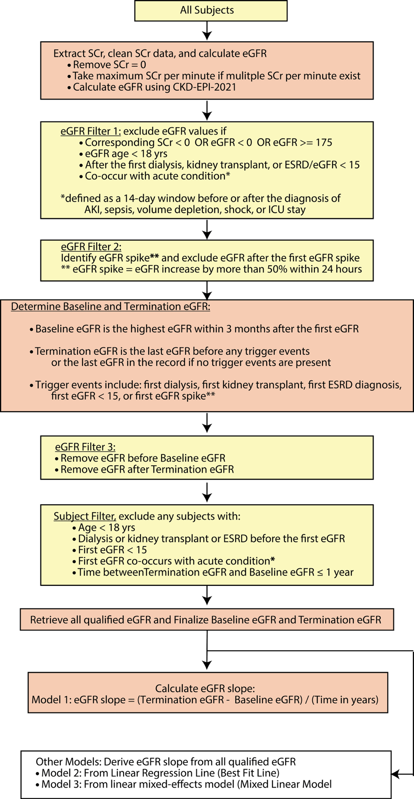
Figure 1. The eGFR Slope (Renal Function Trajectory) Algorithm

Table 1. Coding variables used in the algorithm
Concept codes are provided in the accompanying machine-readable coding file (CKD_coding_V5_SqlServer.sql / coding dictionary). Each coding variable maps a data element to standard OMOP concept IDs; the data-extraction block references these variables by name.
Data element | Coding variable (OMOP)
Serum creatinine | meas.serumCreatinine.omop
Dialysis (diagnosis / procedure) | cond.CkdEsrd_Dialysis.omop, proc.CkdEsrd_Dialysis.omop
Kidney transplant (diagnosis / procedure) | cond.CkdEsrd_kidneyTransplant.omop, obsn.CkdEsrd_kidneyTransplant.omop, proc.CkdEsrd_kidneyTransplant.omop
ESRD (diagnosis) | cond.otherEsrd.omop
Acute kidney injury (AKI) | cond.aki.omop
Prerenal kidney injury | cond.prerenalInjury.omop
Sepsis | cond.sepsis.omop
Volume depletion | cond.volumeDepletion.omop
Shock | cond.shock.omop
ICU visit | proc.ICUvisit.omop (plus site-specific visit type / source value)
Note: Detailed codes are provided in eGFRslope_V4B_DD.txt. Sex (gender_concept_id) and unit normalization (unit_concept_id) are handled inline in the extraction block. Race is optional and is not used by the 2021 race-free eGFR equation.

References
- Khan A, Shang N, Hao L, et al. Electronic medical records-enabled genetic studies of kidney disease progression. (submitted and under review).
- Inker LA, Eneanya ND, Coresh J, et al. New Creatinine- and Cystatin C-Based Equations to Estimate GFR without Race. N Engl J Med 2021;385:1737-1749.
- Levey AS, Stevens LA, Schmid CH, et al. A New Equation to Estimate Glomerular Filtration Rate. Ann Intern Med 2009;150:604-612.
- Kidney Disease: Improving Global Outcomes (KDIGO) CKD Work Group. KDIGO 2012 Clinical Practice Guideline for the Evaluation and Management of Chronic Kidney Disease. Kidney Int 2013;Suppl.:1-150.
- Wang Y, Zhao L, Zhang J, et al. Implications of a Family History of Diabetes and Rapid eGFR Decline in Patients With Type 2 Diabetes and Biopsy-Proven Diabetic Kidney Disease. Front Endocrinol 2019;10:855.
- Gorski M, et al. Genetic loci and prioritization of genes for kidney function decline derived from a meta-analysis of 62 longitudinal genome-wide association studies. Kidney Int 2022;102:624-639.
- Shang N, Weng C, Hripcsak G. A Method for Enhancing the Portability of Electronic Phenotyping Algorithms. AMIA Annu Symp 2016.
- Kramer HJ, Jaar BG, Choi MJ, et al,; National Kidney Foundation Kidney Disease Outcomes Quality Initiative. An Endorsement of the Removal of Race From GFR Estimation Equations: A Position Statement From the National Kidney Foundation Kidney Disease Outcomes Quality Initiative. Am J Kidney Dis. 2022;80(6):691-696.

